Design Patterns and Principles:
- Exercise 1: Implementing the Singleton Pattern
Output:

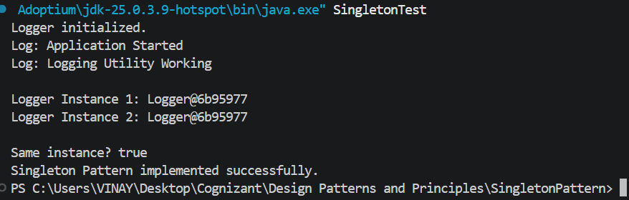

- Exercise 2: Implementing the Factory Method Pattern
Output:
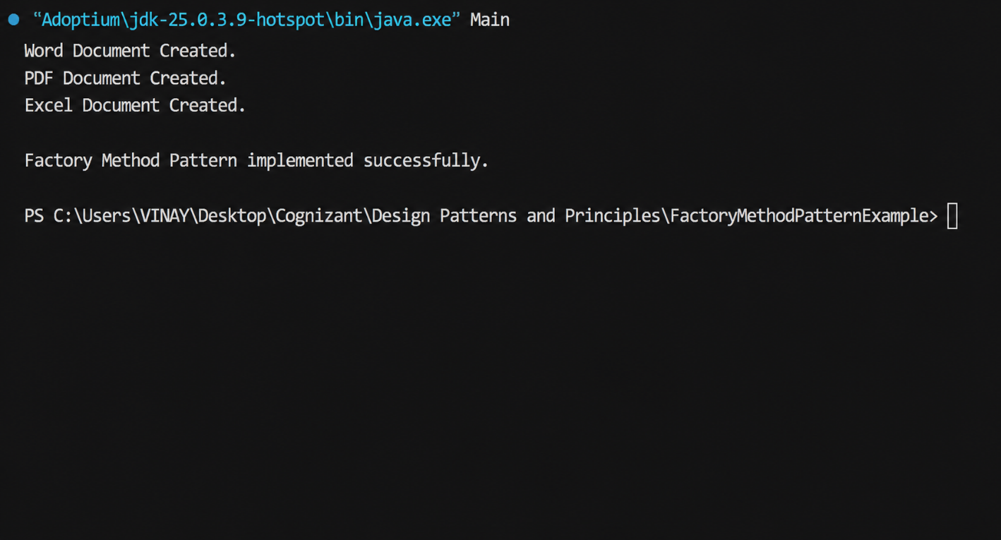

- Exercise 3: Implementing the Builder Pattern
Output:
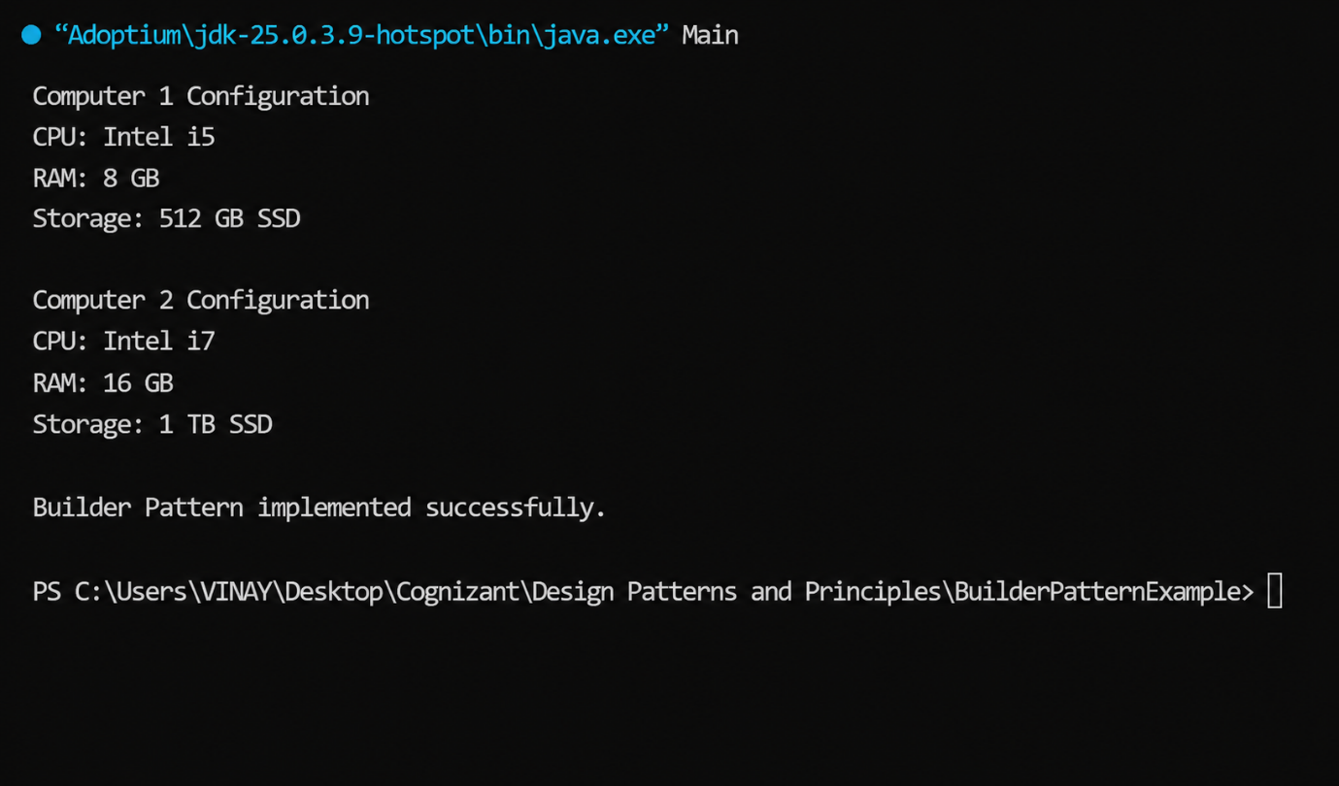
- Exercise 4: Implementing the Adapter Pattern
Output:

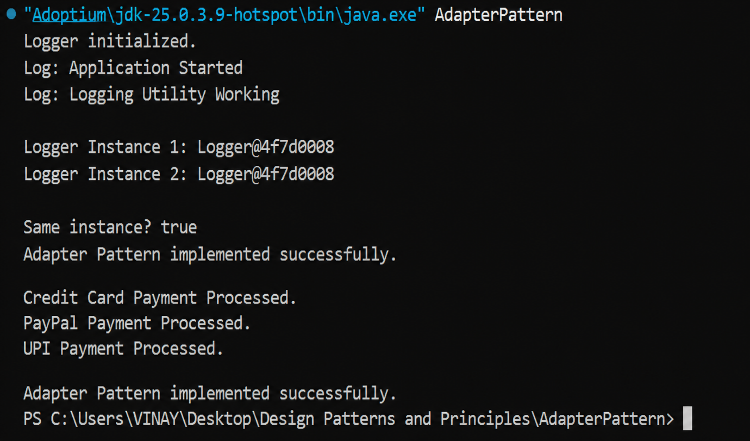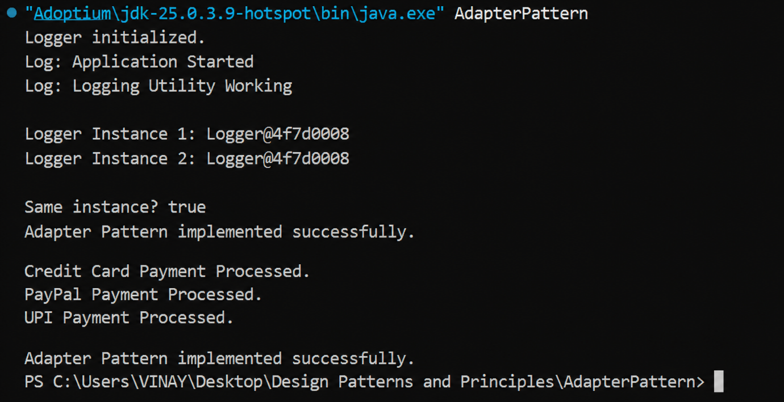
Exercise 5: Implementing the Decorator Patte

- Exercise 5: Implementing the Decorator Pattern
Output:
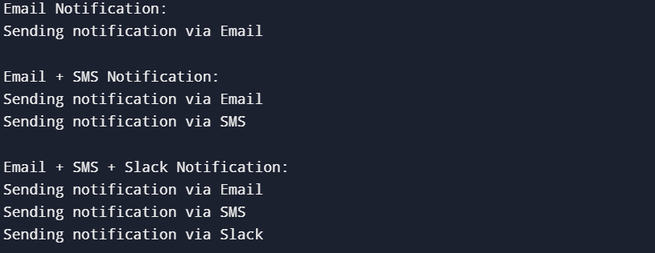

- Exercise 6: Implementing the Proxy Pattern
Output:
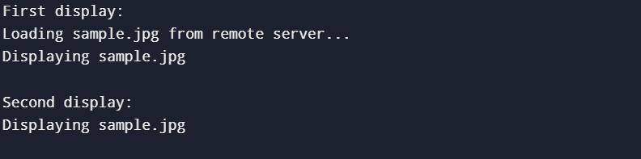

- Exercise 7: Implementing the Observer Pattern
Output:



- Exercise 8: Implementing the Strategy Pattern
Output:

- Exercise 9: Implementing the Command Pattern
Output:
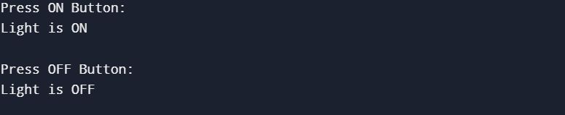

- Exercise 10: Implementing the MVC Pattern
Output:


- Exercise 11: Implementing Dependency Injection
Output:

